**Path=”/”**

How To set Up Project:

1. Download the frontend and Backend Source
2. Open Frontend code in Visual Studio vite and run command npm run dev
3. Open Backend code in intellij and Run the project
4. Now open database and Run the bellow Commands
5. Admin name: Admin
6. User name: User
7. Doctor name: Doctor

* use PatienceManagement;
* insert into roles(name) values ("ROLE_ADMIN");
* insert into roles(name) values ("ROLE_USER");
* insert into roles(name) values ("ROLE_DOCTOR");
* insert into user_roles values (1,2);
* insert into user_roles values (2,1);
* insert into user_roles values (3,3);
* In Util -> PasswordEncoder-> Generate the Password and Paste in Password Field
* insert into user_security(email,name,password,username) values("user@gmail.com","user","$2a$10$KzDoHvizke88n7AUxTTS2e0hmPVyjpQ8pEWMMZ0ZQC.WXVjrxpOGq","user");
* insert into user_security(email,name,password,username) values("admin@gmail.com","admin","$2a$10$qfDXoHKJZWznoB0AMFmJB.d4.G.N2WgJUbom8TTUaqKtE1O6Ea/hy","admin");
* insert into user_security(email,name,password,username) values("doctor@gmail.com","doctor","$2a$10$oSS5yPE.RqLBcPWjbW.2NeOPBDGqg7YUYxA5jyhw2rhTfUWq2tZo6","doctor");

Home Page

Login page

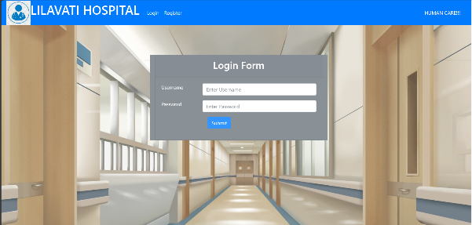

Log in as Admin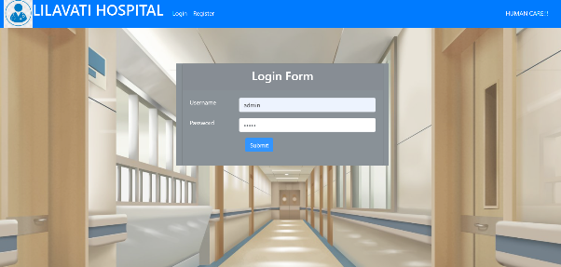

Logged in as Admin



Patient List can be updated by Admin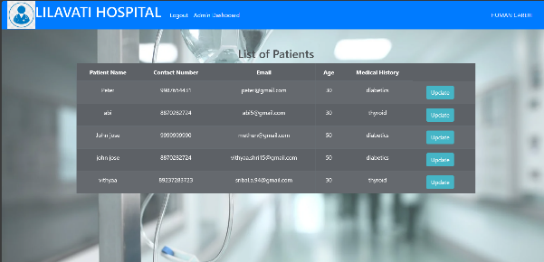

Updating Patient List

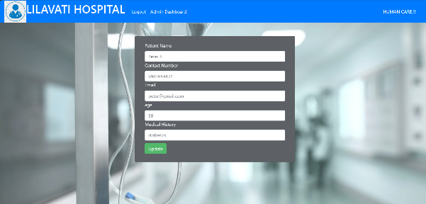

Patient List Updated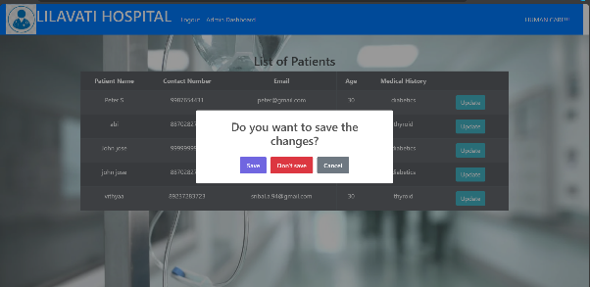



Doctor List can be Updated or Deleted by Admin

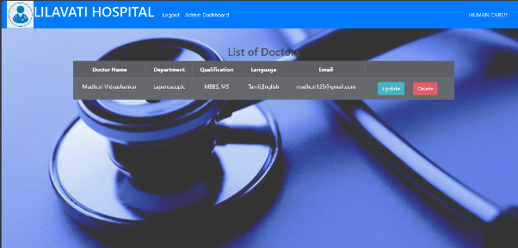

Updating Doctor List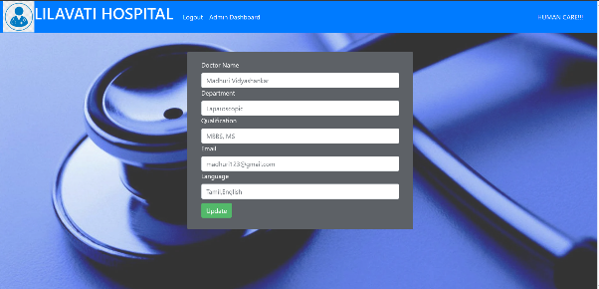



Admin can only View Appointment List

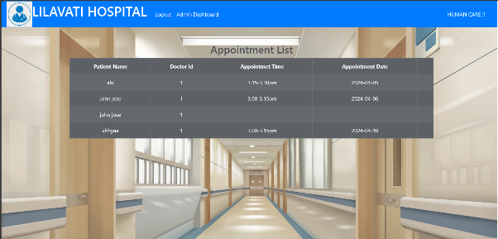

Admin can Add Doctor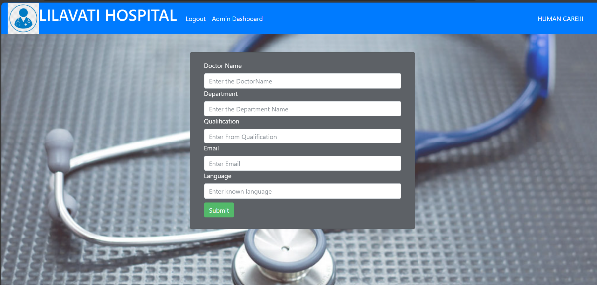

Adding doctor to Backend Doctor List

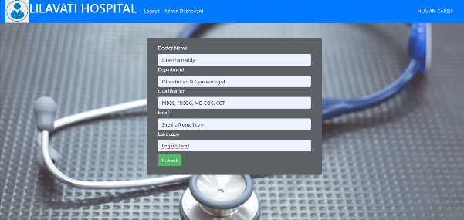

Added Doctor List is Viewed in Doctor List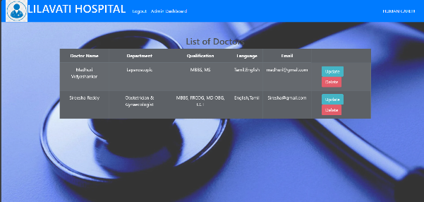

Log in As User

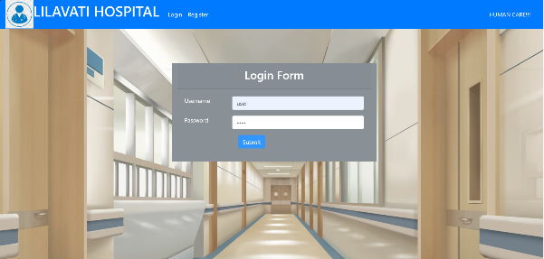

User can Book Appointment, Cancel Appointment, View Prescription prescribed by Doctor 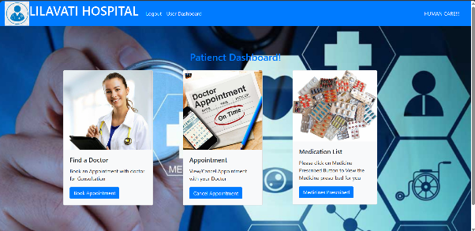

Book Appointment

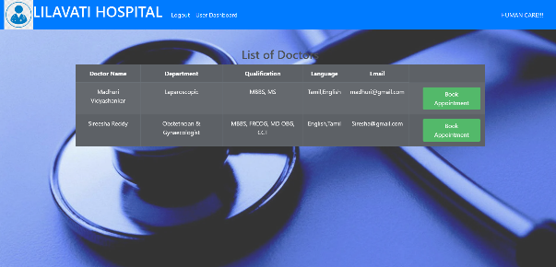

Booking Appointment

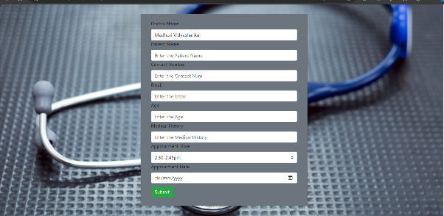

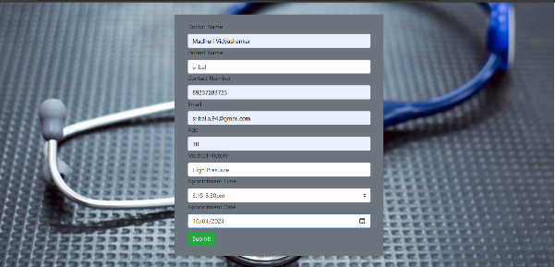

View Or Cancel Appointment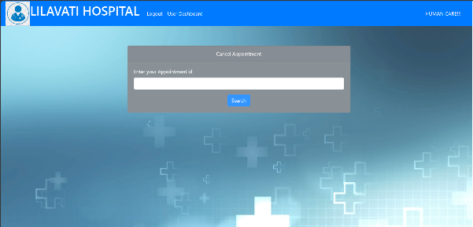

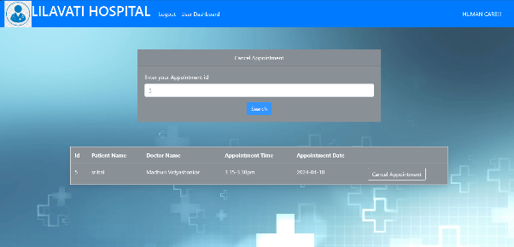

Log in as Doctor

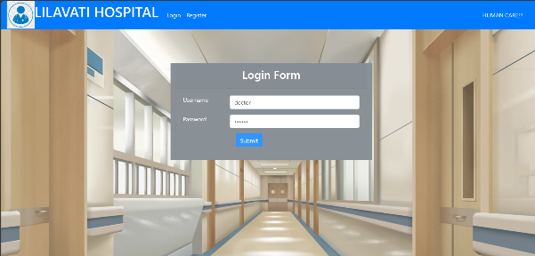

Doctor Can View Appointment List and Add prescription to Patient

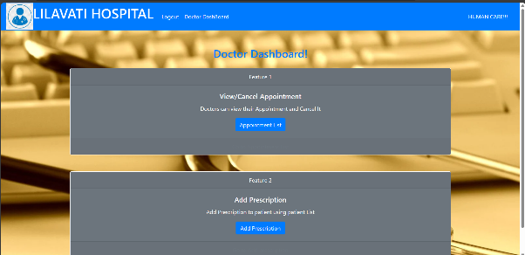

Adding Prescription

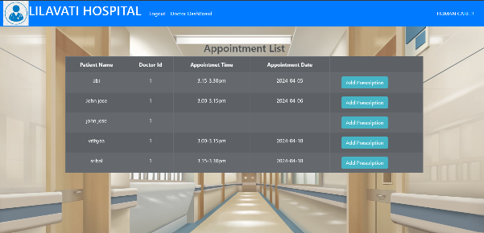

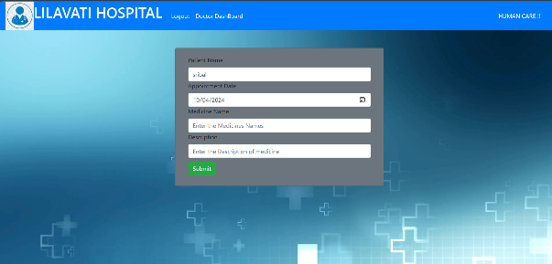

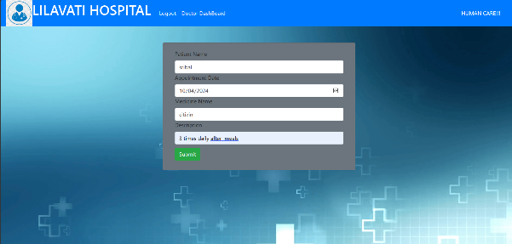

**View Prescription**



